UTEP Office of Sponsored Projects

National Science Foundation Checklist
For guidance on Proposal & Award Policies & Procedures Guide visit: PAPPG
NEW: Principal Investigator Responsibility: Malign Foreign Talent Recruitment Programs. Please see the link below for information. Please note, it is the responsibility of the PI to review in full and certify responsibility, disclosure, and certification in the application. https://new.nsf.gov/policies/pappg/24-1/summary-changes
Prepare your proposal online at:
www.research.gov

PI must provide access to proposal for editing and submission by selecting “SPO/AOR” in Research.gov
  - Guidance on how to initiate and share a proposal
  - Use a start date of at least 6 months from deadline

Additional requirements per proposal specific guidelines:
NSF 25-515: Security, Privacy, and Trust in Cyberspace (SaTC 2.0)
Due: Last Monday in September
- RES: The Research (RES) designation is the focus of the multidisciplinary SaTC 2.0 research program. RES projects are limited to $1,200,000 in total budget, with durations of up to four years. Proposals with a total budget of more than $600,000 have additional requirements including Broadening Participation in Computing and collaboration plans. RES proposals may include an optional Transition to Education (TTE) plan with a budget up to $50,000 (within the RES total budget request) to co-evolve novel educational initiatives in the context of the proposed research.
Limit on Number of Proposals per PI or co-PI: 4
- Optional Transition To Education (TTE) Plans in RES Proposals: Proposers who choose to submit a TTE plan as part of their SaTC 2.0 RES research proposal must describe how successful research outcomes will be transitioned into an educational setting for formal or informal learning. The optional TTE plan must support the design, development, and deployment of innovative cybersecurity or privacy educational materials grounded in research. The TTE plan, not exceeding 2 pages and submitted as a supplementary document, should outline major activities and milestones, and it must detail how the deliverables will be made accessible to the broader academic community. It should also include evaluation with quantifiable metrics for learning assessment, aligned with the accompanying RES evaluation plan.
- Broadening Participation in Computing (BPC) Plans in RES Proposals: All projects with a total budget greater than $600,000 that include an organization (department, school, or institute) that primarily carries out research and education in computer science, computer engineering, information science, and/or other closely related fields, must include a BPC plan (see details in Section V.A. Proposal Preparation).
- Proposal Title: Proposal titles must begin with the acronym SaTC 2.0, followed by a colon, and the acronym that indicates the designation. (SaTC 2.0 core research designation: RES)
- Start Date:To avoid overdue reports blocking award actions during the end of a fiscal year, organizations are discouraged from seeking project start dates between July 2 and September 30 of a given year. Recipient organizations may incur allowable pre-award costs within the 90-day period immediately preceding the start date of the grant subject to the conditions specified in the PAPPG; this will allow support for students or other relevant activities to begin over this period.
- Project Summary: All RES and SEED proposals must include a prioritized list of 1-6 keywords that describe the general area(s) of the investigation, to assist in identifying reviewers with appropriate knowledge and expertise to review the proposal. The list of keywords should be the last paragraph of the Overview section of the Project Summary.

- Project Description:The project description for proposals submitted to the RES and EDU designations is limited to 15 pages, and 10 pages for the SEED designation. See also Section II, Program Description, in this solicitation for additional guidance.
- Supplementary Documents:
1. (required) A list of Project Personnel and Partner Institutions (required. Note: in collaborative proposals, the lead institution should provide this information for all participants):

2. Collaboration Plan (required for all projects with more than one PI and a budget of more than $600,000):
Because the success of collaborative research efforts is known to depend on thoughtful coordination mechanisms that regularly bring together the various participants of the project, all proposals with more than one investigator and a total of more than $600,000 must include a Collaboration Plan of up to 2 pages.

3. Letters of collaboration: Letter of collaboration from academic or industry partners are welcome to document specific contributions they will make to the project. Letters should explicitly describe the resources (e.g., hardware, software, test facilities, data, research expertise) to be provided by the collaborating entity. Any collaboration letter may be no longer than a single page, with fonts and margins with the requirements in PAPPG Chapter II.C.2.

4.Data Management and Sharing Plan (required):

5. Broadening Participation in Computing (BPC) Plans for projects with budgets greater than $600,000: Each project with a budget greater than $600,000 and with a lead or non-lead organization (department, school, or institute) that primarily carries out research and education in computer science, computer engineering, information science, and/or other closely related field must include a BPC plan as a supplementary document at the time of submission. Each plan should begin with the heading "Broadening Participation in Computing (BPC) Plan –" followed by either "Standalone" or "Connected".
6. Optional TTE Plan for RES proposals: The TTE plan should be labeled as "Transition to Education Plan" and should not exceeding 2 pages. The TTE plan should contain the following components: (a) the description of the educational need to be addressed; (b) the novelty of the educational content; (c) how the research or technology will be transitioned into education and its impact on the cybersecurity workforce; (d) the identification of an intended population that will serve as early adopters of the proposed educational content; (e) the deployment plan for implementing/piloting the educational materials; (f) the explanation of the post-grant, long-term sustainability of the educational content; (g) the extent to which learning experiences will feed back into research (if applicable); and (h) the justification of the TTE budget for the effort, which may include up to $50,000 within the RES total budget request.
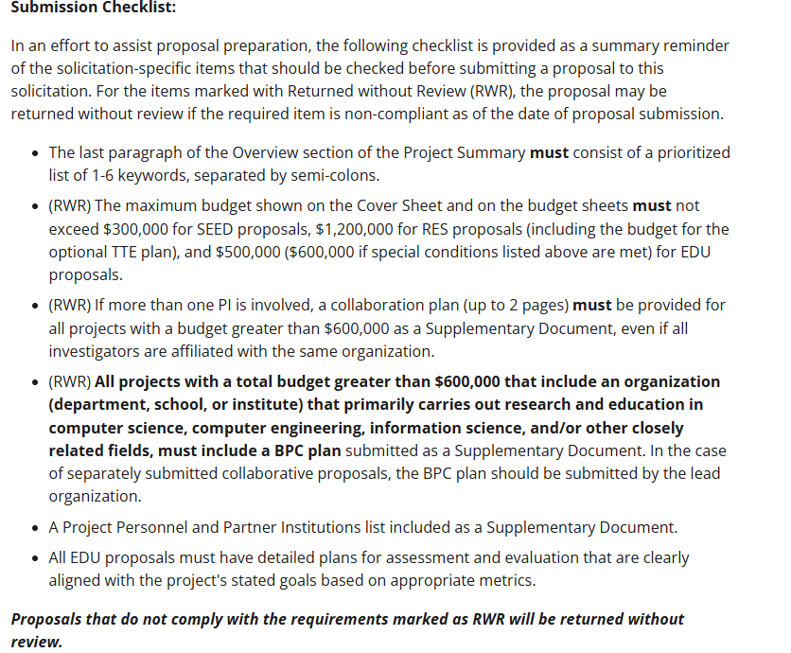

Document | Document Requirements
Formatting Requirements | - Font (Arial/ Palatino/Courier New 10 pts or larger, Times New Roman/Computer Modern 11 pt)  - 1 inch margins on 8.5 x 11 inch standard page  - All documents must be in PDF format, unless otherwise specified  - For proposals submitted via Research.gov, the system will automatically paginate a proposal. Each section of the proposal that is uploaded as a file should leave out page numbering unless otherwise directed within Research.gov  - Landscape format is allowed
Cover Sheet | - Select countries for any international collaborations, including travel to international conferences (if destination unknown, indicate “worldwide”)  - Mark IACUC or IRB if applicable  - New box available for off campus research  - Funding of a “Foreign Organization or Foreign Individual” must be checked off. This includes consultant or subcontracts.
Project Summary | - Must contain 3 separate section headers:  - Overview, Intellectual Merit, Broader Impacts.  - Headings must be on their own line.  - 1 page maximum
Project Description | - Usually 15 page limit (refer to solicitation for specifics)  - Follow NSF guide for content, which includes, but is not limited to:  - The Project Description must contain, as a separate section within the narrative, a section labeled "Broader Impacts" on its own line  - Results from Prior NSF Support in the past five years  - No hyperlinks allowed  - If applicable, include justification for “Funding of a Foreign Organization or Foreign Individual”
References Cited | - All author names are listed and fully written out (i.e. no “et al”)  - Names appear in the order they appear in publication  - Include article or chapter title and, for book chapters, book title  - Include start and end page numbers  - URL allowed/optional in citations
Budget(s) | - Reference guidelines for specifics  - Absolutely no cost share unless RFA requires it
Budget Justification(s) | - 5 page limit for the lead proposal plus, if applicable, up to 5 additional pages per subcontract  - No cost sharing language  - If more than 2 months salary requested, justification must be included  - Include rates of pay by individual for senior personnel, postdocs and other professionals  - Travel must be itemized. Conference travel must be justified. Domestic travel is only for the US, territories and possessions  - Foreign travel must include the names of the countries and dates of visit, if known  - Additional participant support categories such as incentives, gifts, and t-shirts must be itemized and justified  - Consultant services must be itemized and justified with expertise, affiliation, daily compensation rate, expected service dates  - Computing devices can be included under supplies and should be detailed in the budget justification  - Incentive payments for human subjects should be subject to indirect costs and included on ‘G. Other Direct Costs, 6. Other’ of the NSF budget  - Indirect is not allowed on Participant Support, which includes stipends or subsistence allowances, travel allowances, and registration fees paid to or on behalf of participants or trainees (but not employees)  - Trainers and speakers must be budgeted under other direct costs, not participant support  - Indirect amounts should be included in the budget justification.  - For subcontracts, use their negotiated rate. If one doesn’t exist, use 10%
Facilities, Equipment and Other Resources | - No cost sharing language (i.e. no exact amounts to be contributed to the project) although other resources may be included  - Includes description of unfunded collaborations  - Include description of unfunded senior personnel role(s) on project  - Include here any collaborations that are not in the budget  - Must indicate all organizational resources that are necessary and available to the project (do not include quantifiable amounts)
Biosketch | - Effective October 2023, must use SciENcv approved format for biosketches  - Provided separately for each PI, all Co-PIs, and any senior personnel, regardless of role  - No page limit  - Includes all and only the required elements:  - Professional Preparation in reverse chronological order by start date:  - Institution, location, major, degree, and year  - Appointments in reverse chronological order by start date  - Products (max 10)  - Up to 5 most closely related and up to 5 other significant publications  - Certification (signature and date)  - Must certify that they are not a party to a MFTRP
Synergistic Activities Document | - Each individual identified as senior/key personnel must include a one-page document with up to five examples that demonstrate the broader impact of the individual’s professional and scholarly activities that focus on the creation, integration, and transfer of knowledge.  - This document is submitted as part of the Senior/Key personnel documents in Research.gov.
Current & Pending Support | - Effective October 2023, must use SciENcv approved format for current and pending support  - Provided separately for PI, all Co-PIs, and any senior personnel regardless of role  - List current proposal as pending support  - Useful table to determine types of activities to disclose  - Must certify that they are not a party to a MFTRP
Collaborators and Other Affiliations | - Collaborators and Other Affiliations provided separately for each PI, all Co-PIs, and any senior personnel, regardless of role  - Upload in .XLS format rather than PDF
NEW  Data Management Plan (The Research.gov tool referred to in this section will be released on April 27, 2026.) | - Proposals must include a DMSP created using the tool implemented on Research.gov.  - Data Management Plan guidance  - DMSP may include only the statement that no detailed plan is needed, for example, if no data, samples, physical collections, software, curriculum materials, or other materials are to be produced during the project. However, such a statement must be accompanied by a clear justification.
Mentoring Plan | - Mentoring Plan has been expanded, now requiring a plan for graduate students as well as postdoctoral researchers supported on a project  - 1 page limit
Other Supplementary Documentation | - Allowed or required per guidelines  - Letters of Collaboration only (no letters of support, limit to stating intent to collaborate, should not contain endorsements or evaluation of project)  - Letters of collaboration from unfunded collaborations can be included  - Biosketches for Other Personnel or Equipment proposals  - For postdocs, other personnel, or students can include a clearly identified freeform biosketch in this section  - For equipment proposals, must provide for each auxiliary user:  - (a) Short biographical sketch; and  - (b) List of up to five publications most closely related to the proposed acquisition. Such information should be clearly identified as "Equipment Proposal" biographical information and uploaded as a single PDF file in the Other Supplementary Documents section of the proposal
For Collaborative Proposals:  The non-lead organization should work offline with the lead organization for linking of the proposals.  https://www.research.gov/research-web/content/aboutpsm#psm | A Collaborative Proposal is one in which investigators from two or more organizations wish to collaborate on a unified research project.  The following sections are required for a collaborative proposal submitted by:  https://new.nsf.gov/policies/pappg/24-1/ch-2-proposal-preparation#ch2E3
  Lead Organization | Non-Lead Organization
  - Cover Sheet | - Cover Sheet
  - Project Summary | - Table of Contents (automatically generated)
  - Table of Contents (automatically generated) | - Budget and Budget Justification
  - Project Description | - Facilities, Equipment and Other Resources
  - References Cited | - Biographical Sketch(es)
  - Budget and Budget Justification | - Current and Pending (Other) Support
  - Facilities, Equipment and Other Resources | - Collaborators & Other Affiliations Information
  - Biographical Sketch(es) | - Synergistic Activities
  - Current and Pending (Other) Support
  - Collaborators & Other Affiliations Information
  - Synergistic Activities
  - Data Management and Sharing Plan
  - Mentoring Plan (if applicable)

